San Diego Creative Arts Project

presents

ANNIE REBOOTED

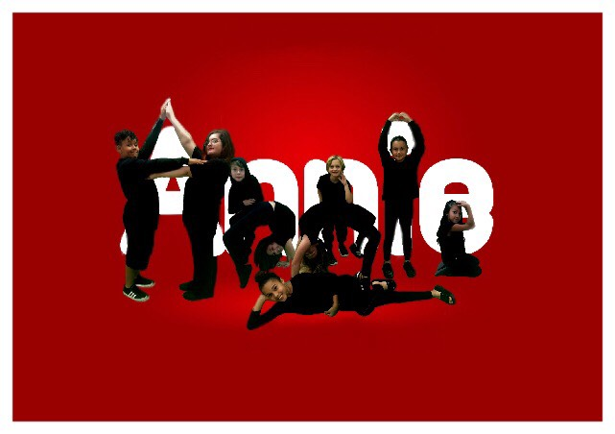

February 15 & 16, 2019

St. Paul’s Episcopal Cathedral~ Great Hall

**ANNIE Rebooted Synopsis & Director’s Note**

*A new look at America’s Favorite Orphan*

San Diego Creative Arts Project is proud to present a new original script based on the Little Orphan Annie comic strip. Set in modern day Los Angeles, Annie Rebooted is a modern look and thought provoking commentary of current and age old issues - regarding the state and situation of being an orphan. Annie represents the young at heart and their hopes and dreams. She represents all of the orphans and their struggle with coming of age while on their own.

Annie and friends deal with adults and the agendas that they set for the orphans. By chance she is chosen to become the guest of Mr. Oliver Warbucks, one of the richest men in LA, who has his own agenda to look good by taking in an orphan for Christmas. Annie in her honesty and positive attitude and sweetness, changes everyone’s lives around her. She is adopted by Mr. Warbucks and he promises to find homes for all of her orphan friends. He also draws out and helps to apprehend the people (Ms. Hannigan and her crew), who are trying to use the orphans to their own advantage.

This has been a wonderful, heartfelt production, with the most endearing cast and families, we are blessed to have worked with yet.

Laura Hodge

Executive Artistic Director

**SAN DIEGO CREATIVE ARTS PROJECT**

*Proudly Presents*

ANNIE REBOOTED!

**Original Script, Direction, & Choreography**

Laura Hodge

**Musical Direction, Vocal Coach**

Tammy Milner

**San Diego Creative Arts Project** is committed to changing youth and adult lives for the better through the performing arts. After five years in existence, this is SDCAP’s 14th Youth Musical Theatre production, and the fifth original script adaptation in the “Rebooted” series, two of which were Bi National productions, with students from San Diego and Mexico. SDCAP believes whole -heartedly that students excel with proper training by experienced professionals.

We are training the “Stars of Tomorrow.

San Diego Creative Arts Project is 501c3 Non Profit

**CAST**

**ANNIE** Gabrielle Hawkins

**OLIVER WARBUCKS** Fabian Garcia

**MS. HANNIGAN** Paola Mosler

**GRACE** Rhiannon Fallon

**ROOSTER** Isabel Mattick

**LILY ST. REGIS** Tahlia Burnett

**PEPPER**  Kailyn Martinez

**REESE** Sophia Guzman

**SYDNEY**  Dylan Hochman

**CHANCE** Lucas Mosler

**MUSICAL NUMBERS CHARACTER(S)**

**ACT 1**

“OOOH CHILD” ANNIE, ORPHANS

“KIDS IN AMERICA” ANNIE, ORPHANS

“LIVING IN THE CITY” FULL CAST

~~~~~15 MINUTE INTERMISSION~~~~~

**ACT 2**

“24 KARAT MAGIC” MS. HANIIGAN, ROOSTER, LILY

“DON’T LET THE SUN GO DOWN ON ME” ANNIE

“DON’T STOP THINKING ABOUT TOMORROW” FULL CAST

**Cast Bios**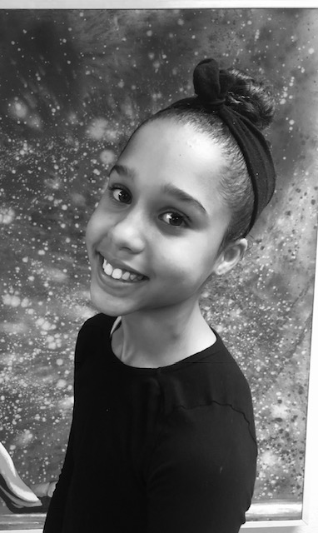

**Gabrielle Hawkins - “ANNIE”** “Gaby” Hawkins is 11 years old. She enjoys drawing, animating, playing soccer, rock climbing and singing. She has performed in several roles in local theatre productions. The titles range from Hairspray, Alice in Wonderland, and Peter Pan Rebooted. Her favorite musical is Hamilton. Gaby is part of her school cheer squad and participated in the choir group. She recently sang “A Million Dreams” at the 31st All Peoples Celebration with Alliance San Diego.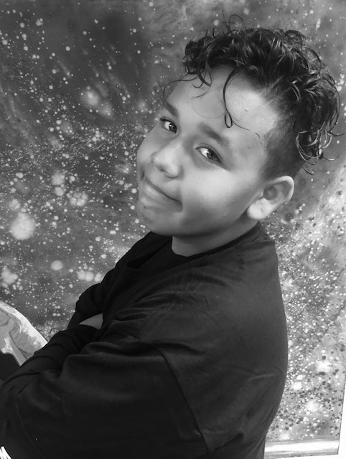

**Fabian Garcia - ”MR. WARBUCKS”** Fabian is 11 years old. has performed in a play called compose yourself with his fifth grade class. This is his first year with SDCAP and he loves it but other than being in SDCAP He also plays baseball, football and loves to draw in his spare time.

**Rhiannon Fallon -”GRACE”** is 15 years old and in 10th grade at Compass Charter School. This is her first show at SDCAP and the first show that he/she has been in. When Rhiannon is not performing, she enjoys listening to music, singing, and creative writing, and creating visual art. Some of Rhiannon's favorite musicals are Hamilton and Wicked.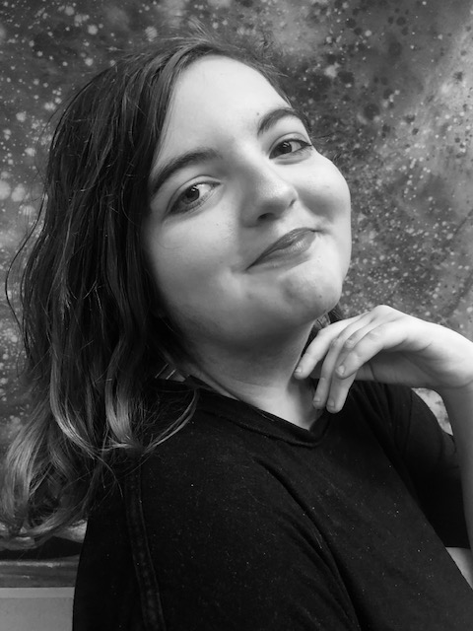

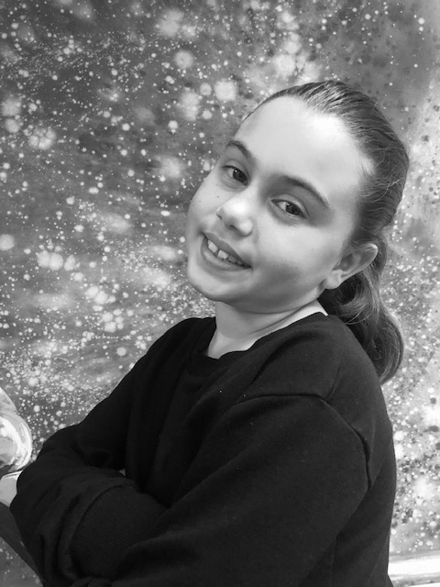

**Kailyn Martinez** - **“PEPPER”** is 9 years old. She is in 3rd grade at Mueller Charter. This is her fourth SDCAP production she was small Alice, in Alice In Wonderland Rebooted, Aladdin Rebooted, and in Peter Pan Rebooted. In Annie Rebooted she is playing pepper the bossy Little Orphan. This part of Pepper fits her perfectly. In her spare time when not Dancing, Singing, and Acting, she loves to do tik tok (musically) and loves to play with Honey her dog. Kailyn is a Beautifully, sweet and talented girl. We are so proud of what she has done so far!

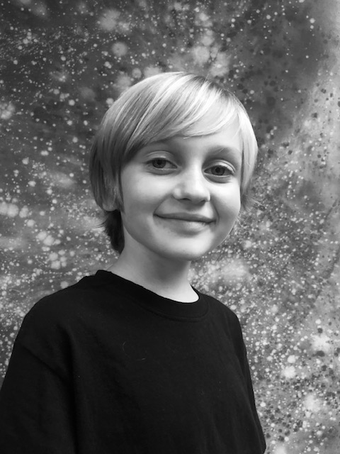

**Dylan Hochman - “SYDNEY”** is 7 years old , in 2nd grade at High Tech Elementary. This is his 1st show at SDCAP. When not performing, he enjoys spending time with his family, and watching Hell’s Kitchen, Oak Island, The Masked Singer, and TV singing and talent competitions. He plays baseball, tennis, loves bike rides around North Park, and walking his dog, Millie. He loves to draw and color, his favorite color is orange. He’s addicted to Fortnite and loves to dance! Dylan is a huge fan of KISS, and Brandi Carlile. His favorite musical is Alexander Hamilton. Dylan played the lead role of “The Mouse” in his school’s performance of The Gruffalo.



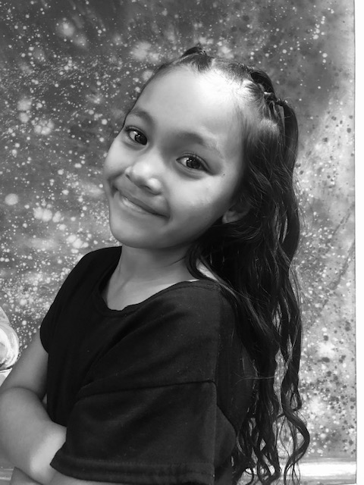

**Sophia Guzman - “REESE”** is 7 years old and this is her first year with SDCAP. She is a free spirited kid who loves music, playing soccer, and going on scary rides. “She is awesome” she wanted me to add!

**Lucas Mosler - “CHANCE”** 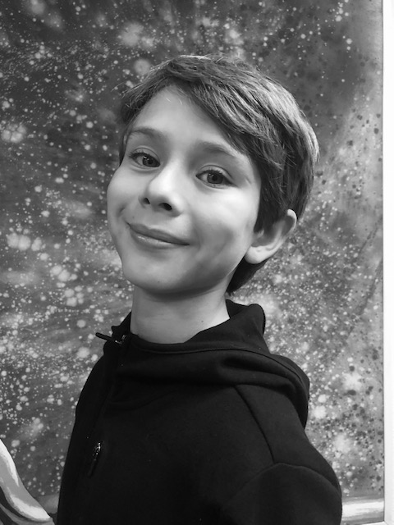

This is Lucas Mosler’s first time performing for SDCAP as the orphan, “Chance.” In past years, he has participated in German Choir performances. He loves role-playing as his favorite superheroes and other movie characters. He also enjoys contemporary pop and is great at memorizing songs. Lucas is 9 years old.

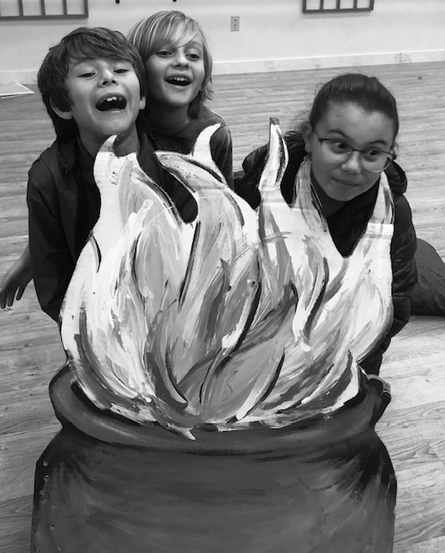

**Creative Team Bios**

**Laura Hodge** *Director, Choreographer*

Executive Artistic Director-Writer, Director, Choreographer, Master Educator - Performer Artistwhose work is respected from Coast to Coast, and Baja Ca. Prior to **SDCAP**, Artistic Director of award winning companies in Pittsburgh, Pa., training with Pittsburgh Ballet Theatre, Point Park University, Pittsburgh Playhouse Conservatory, Carnegie Mellon University, NYC and LA. Performed in Musical Theatre, Dance Companies, National Tours, Film, TV, Pittsburgh & San Diego Symphonies, Member of SAG-Screen Actor’s Guild, & Voice Over work. Teaching, Directing, Choreography credits: Choreography for Film star Oscar Isaac. San Diego Arts 4 Learning, Southwestern College, CEART Playas de Rosarito, Point Park University, University of Pittsburgh, Millenium (L.A.), Malashock Dance, San Diego Junior Theatre, San Diego Civic Youth Ballet, Mary Murphy’s (“So You Think You Can Dance”) Champion Ballroom, and private coaching.



**Tammy Milner***Musical Director and Voice Coach*

Tammy Milner was born in Cincinnati where she graduated from Marian H. S., and attended University of Cincinnati - College Conservatory of Music , where she majored in Opera and piano composition. As a Jazz singer and pianist she toured, did studio work with Bootsy Collins, Corporate Events, sang National Anthem for Tony Gwynn Day, and was certified in working with children with special needs through music and movement after attending Palomar College. Tammy has had her own recording studio - TJ dreams studio. Tammy has been a Minister of music for several churches, and most recently St. Paul United Methodist, where she works with several youth groups as musical director. With her own band, she wrote original songs, under the stage name Lady Blue and toured the Southern Circuit.Tammy has worked as a performer and/or musical director at Purlie Playhouse in the Park, Porgy and Bess, DreamGirls, and Musical Director for SDCAP’s Aladdin Rebooted and Peter Pan Rebooted. Tammy currently teaches private voice and piano at SDCAP.

**Shout Outs and Congratulations:**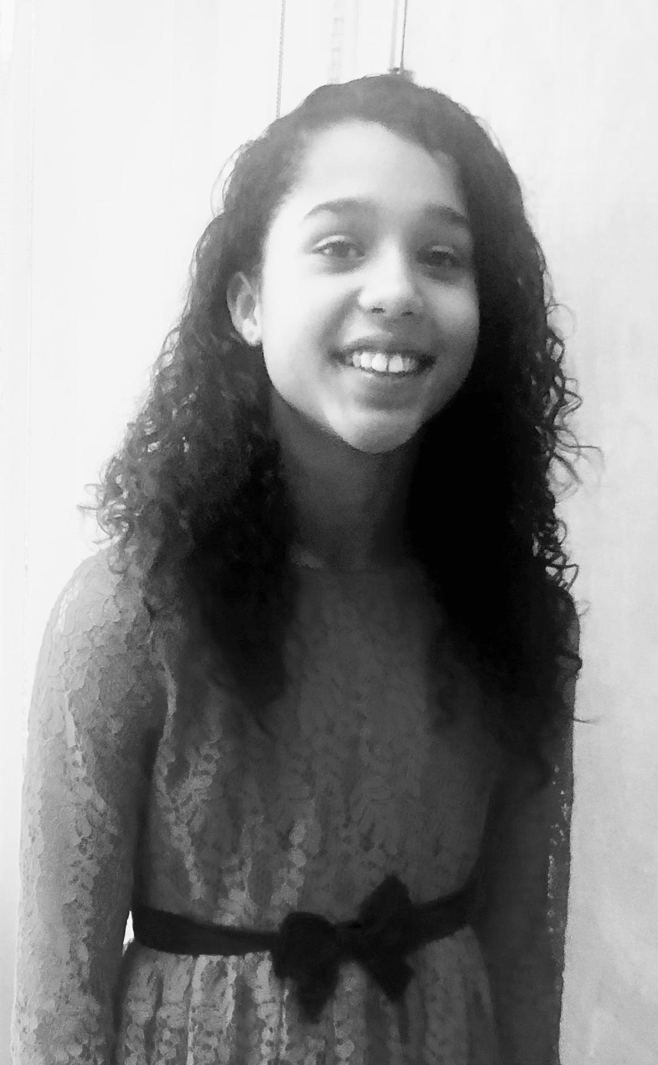

Gaby, your family and friends at SDCAP are so proud and inspired by your endless dedication and growth in your work. You are a Triple Threat!!!

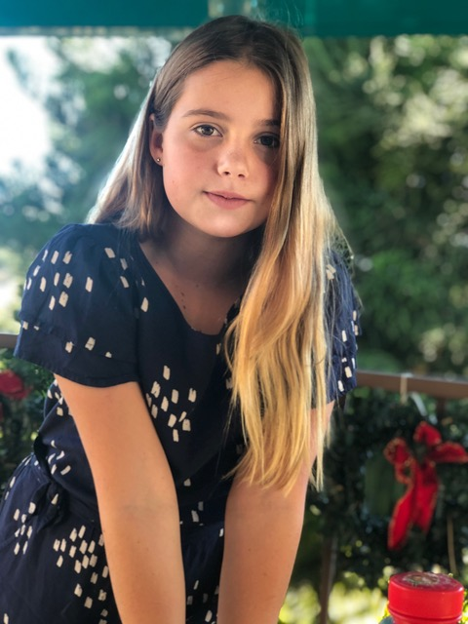

Break a leg,beautiful girl.

We love you, Tahlia!

Mom, Dad, Evelyn, June and Josie

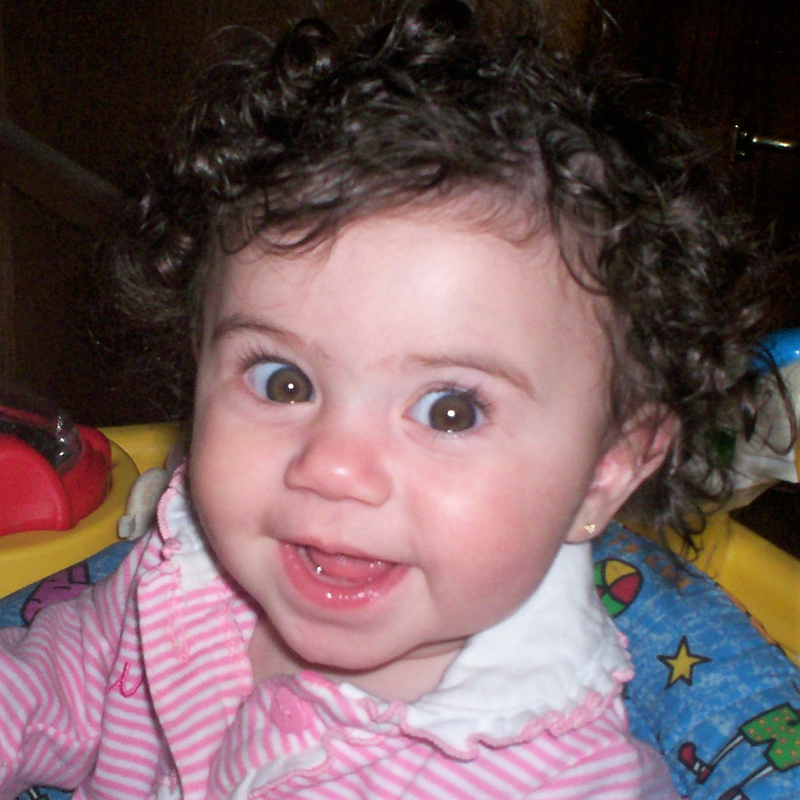

Congratulations, Kailyn

We love to see that smile and we're so proud of you!

Love You! Mom, Dad and Kendell

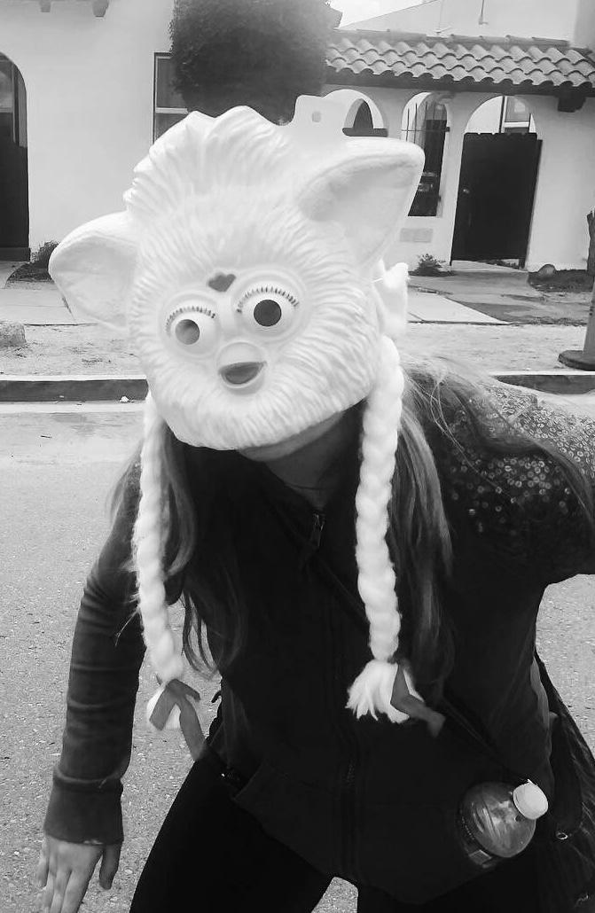

Izze, Merde and break a leg! I love you my funny and talented girl! ~ Mom

|  |  |  |  |
| --- | --- | --- | --- |
| **Special Thanks!**  Super big thanks to all of the cast and their families who believe in this production, and made this miracle happen!  Thank you to St Paul’s Episcopal Cathedral, Susan Jester, Kathleen Burgess, Bob Eisele, “Charley” Juan Figueroa, David Silva,  Jenny Martinez, David Kamatoy,  The Soiree Band, and Hip Hop Dance crew - So Extra Project- Bernadine, Rosemary Snyder. | 1 | 1 |  |
| **SDCAP would like to welcome Alison Marae and Little CatBird Theatre!**       |  | | --- | |  |       **UPCOMING at SDCAP**  **\* Hip Hop Class with So Extra** | | |
| **\*Home School Approved Classes** | | |  |
| **\*ALICE REBOOTED AUDITIONS!!!** | | |  |

**SUMMER CAMPS!!!**

**One week, 9:00am-3:00pm**

**Musical Theatre & Dance Camps**

**June 18 - August 9**

[**sdcreativearts@gmail.com**](mailto:sdcreativearts@gmail.com)

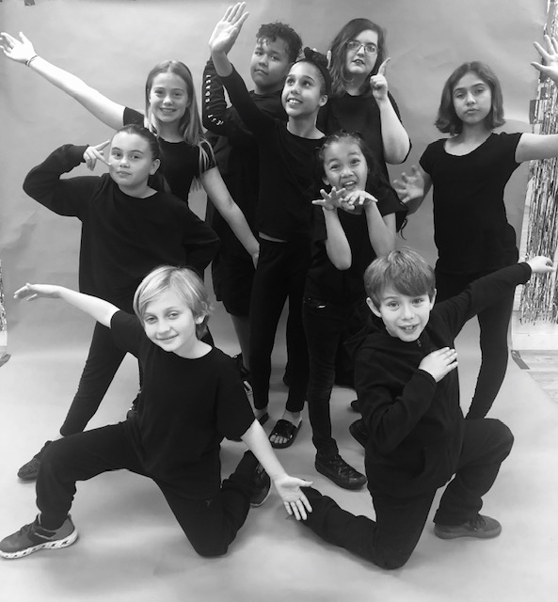

**AUDITIONS!!!**

**ALICE REBOOTED!**

**SDCAP** is proud to present our acclaimed Retelling of

**Alice in Wonderland**

**Auditions: March 21 & 23**

by Appointment [**sdcreativearts@gmail.com**](mailto:sdcreativearts@gmail.com)

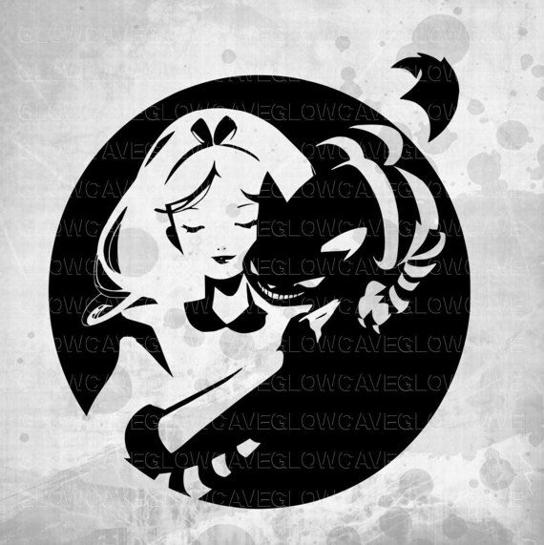

**Classes for Kids and Adults**

Ballet, Tap, Jazz, Acting, Musical Theatre, Hip Hop, Yoga, Ballroom & Latin, Voice, Audition Prep, Private Coaching and Choreography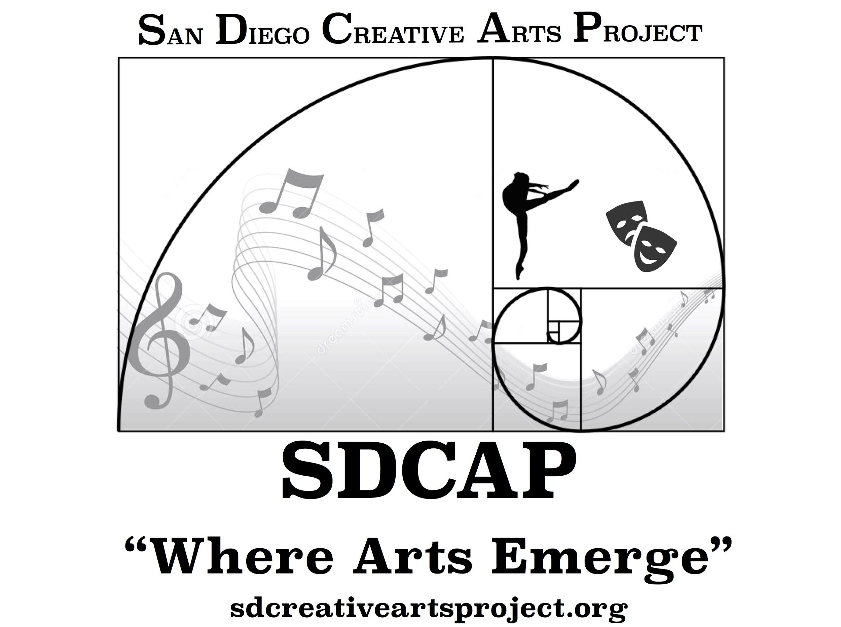

**sdcreativearts@gmail.com**

Facebook: @SDCreativeArtsProject

Instagram: @sdcreativearts